
American International University- Bangladesh (AIUB) Faculty of Engineering (FE)

Course Name: | DATA COMMUNICATION | Course Code: | COE3103
Semester: | Spring 2024-25 | Section: | L
Faculty: | DR. AMIRUL ISLAM | Group: | 08
Experiment No: | 09
Experiment Name: | Message Passing and Receiving Using Modulator

Submitted by (NAME): | MD. YEAHYEA JAM | Student ID: | 23-50187-1
Group Members |  | Name | ID
 | 1. | MD. MIRAN HOSSAIN | 22-46175-1
 | 2. | FAHMIDA RAHMAN | 22-48483-3
 | 3. | MOHSIN IBNA HOSSAIN | 23-50194-1
 | 4. | MD. YEAHYEA JAM | 23-50187-1
 | 5. | HOSSAIN MOHAMMAD SAMI | 23-51354-1

Performance Date: | 12/05/2025 | Due Date: | 19/05/2025
Marking Rubrics (to be filled by Lab Instructor)
Category | Proficient [6] | Good [4] | Acceptable [2] | Unacceptable [1] | Secured Marks
Theoretical Background, Methods & procedures sections | All information, measures and variables are provided and  explained. | All Information provided is sufficient, but more explanation is  needed. | Most information is correct, but some information may be  missing or inaccurate. | Much information is missing and/or inaccurate.
Results | All of the criteria are met; results are described clearly and accurately; | Most criteria are met, but there may be some lack of clarity and/or incorrect information. | Experimental results don’t match exactly with the theoretical values and/or analysis  is unclear. | Experimental results are missing or incorrect;
Discussion | Demonstrates thorough and sophisticated understanding.  Conclusions drawn are appropriate for  analyses; | Hypotheses are clearly stated, but some concluding statements not supported by data or data not well  integrated. | Some hypotheses missing or misstated; conclusions not supported by data. | Conclusions don’t match hypotheses, not supported by data; no integration of data from different sources.
General formatting | Title page, placement of figures and figure captions, and other  formatting issues all correct. | Minor errors in formatting. | Major errors and/or missing information. | Not proper style in text.
Writing & organization | Writing is strong and easy to understand; ideas are fully elaborated and connected; effective transitions between sentences; no  typographic, spelling, or grammatical errors. | Writing is clear and easy to understand; ideas are connected; effective transitions between sentences; minor typographic, spelling, or grammatical errors. | Most of the required criteria are met, but some lack of clarity, typographic, spelling, or grammatical errors are present. | Very unclear, many errors.
Comments: |  |  |  | Total Marks (Out of 30):

Title
Message Passing and Receiving Using Modulator
Abstract:
This experiment is designed
1. To understand the concept of message encoding and decoding.
2. To understand the concept of serial transmission and reception of message.
3. To develop understanding of data transmission and reception process.
Introduction:
In digital communication systems, transmitting and receiving text messages over physical media requires a series of signal processing steps to ensure that the information is accurately conveyed. This experiment focuses on understanding the fundamental principles of message encoding, serial data transmission, modulation, demodulation, and message decoding.
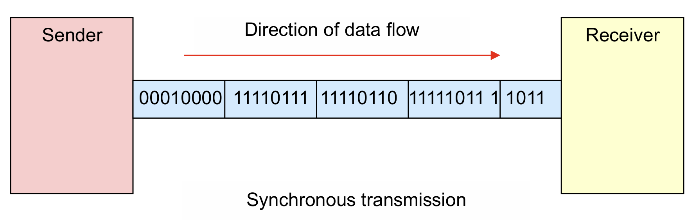
Fig1: Synchronous transmission
The process begins at the transmitter end, where the input message is first encoded into binary form using ASCII codes. These binary sequences are then serialized and converted into digital signals. To effectively transmit the digital data over analog waveform channels such as twisted pair cables or wireless RF links, modulation techniques such as Amplitude Shift Keying (ASK) or Frequency Shift Keying (FSK) are applied.
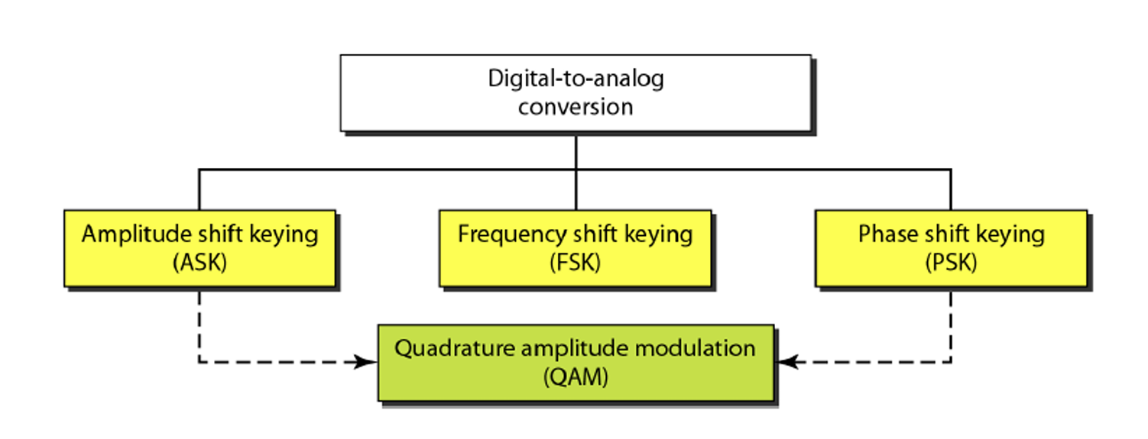
Fig2: Digital to Analog Conversion

At the receiver side, the analog signal undergoes demodulation to recover the original binary sequence. The binary data is then decoded back into human-readable text. Due to the presence of channel noise, especially modeled here as Additive White Gaussian Noise (AWGN), the receiver must handle and correct for possible signal impairments.

This experiment provides practical experience in simulating the entire communication chain—from message encoding to signal modulation, channel noise modeling, and message recovery—thereby reinforcing theoretical concepts with hands-on implementation using MATLAB.

Results and Discussion
Performance Task for Lab Report
(a) Transmit a text message ‘We Enjoy Data Comm’ as analog signal using QPSK. Show the binary data representing the text, show the digital signal, and show the analog signal.
(b) Show the received analog signal assuming the communication channel has an SNR of 50 dB.
(c) Recover the text ‘We Enjoy Data Comm’ from the received signal.
Function asc2bin Code:
function dn = asc2bn(txt)
dec=double(txt) %//Text to ASCII (decimal)
p2=2.^(0:-1:-7) %// 2^0,2^-1,.......,2^-7
B=mod(floor(p2'*dec),2) %//Decimal to binary conversion
%//Columns of B are bits of chars
dn=reshape(B,1,numel(B));%//Bytes to serial conversion
end

Function bin2asc Code:
%//bin2asc Serial binary to ASCII to text conversion
function txt = bin2asc(dn)
L=length(dn); %//Length of input string
L8=8*floor(L/8); %//Multiple of 8 Length
B=reshape(dn(1:L8),8,L8/8); %//Cols of B are bits of chars
p2=2.^(0:7); %//power of 2
dec=p2*B; %//Binary to decimal conversion
txt=char(dec); %//ASCII (decimal) to txt
end

Code:
clc;
clear all;
close all;

%//%// Part (a): Transmit message as analog signal using QPSK
Transmitted_Message = 'We Enjoy Data Comm';

%// Convert Information Message to bits
x = asc2bn(Transmitted_Message); %// Binary Information
bp = 1e-6; %// bit period
disp('Binary information at Transmitter:');
disp(x);

%// Representation of transmitting binary information as digital signal
bit = [];
for n = 1:length(x)
if x(n) == 1
se = ones(1,100);
else
se = zeros(1,100);
end
bit = [bit se];
end
t1 = bp/100:bp/100:100*length(x)*(bp/100);

figure;
subplot(4,1,1);
plot(t1,bit,'lineWidth',2.5); grid on;
axis([0 bp*length(x) -0.5 1.5]);
ylabel('Amplitude (volt)');
xlabel('Time (sec)');
title('Original Binary Data');

%// QPSK Modulation
br = 1/bp; %// bit rate
f = br*2; %// carrier frequency (lower for QPSK)
t2 = bp/99:bp/99:bp;

%// Split into I and Q channels
even_bits = x(1:2:end);
odd_bits = x(2:2:end);

%// Ensure equal length by padding if necessary
if length(odd_bits) < length(even_bits)
odd_bits = [odd_bits 0];
end

%// Modulate I channel (even bits)
m_i = [];
for i = 1:length(even_bits)
if even_bits(i) == 1
y = cos(2*pi*f*t2);
else
y = -cos(2*pi*f*t2);
end
m_i = [m_i y];
end

%// Modulate Q channel (odd bits)
m_q = [];
for i = 1:length(odd_bits)
if odd_bits(i) == 1
y = sin(2*pi*f*t2);
else
y = -sin(2*pi*f*t2);
end
m_q = [m_q y];
end

%// Combine I and Q channels
m = m_i + m_q;
t3 = bp/99:bp/99:bp*length(even_bits);

subplot(4,1,2);
plot(t3,m);
axis([0 bp*length(even_bits) -2 2]);
xlabel('Time (sec)');
ylabel('Amplitude (volt)');
title('QPSK Modulated Signal at Transmitter');

%//%// Part (b): Show received signal with 50 dB SNR
disp('********************');
disp('Message transmitted through a Transmission medium');
disp('********************');

%// Channel Noise with 50 dB SNR
t4 = bp/99:bp/99:bp*length(even_bits);
Rec = awgn(m,50,'measured');

subplot(4,1,3);
plot(t4,Rec);
axis([0 bp*length(even_bits) -2 2]);
xlabel('Time (sec)');
ylabel('Amplitude (volt)');
title('Received signal at Receiver (50 dB SNR)');

%//%// Part (c): Recover the text from the received signal
%// QPSK Demodulation
ss = length(t2);
mn_i = []; %// I channel bits
mn_q = []; %// Q channel bits

for n = ss:ss:length(Rec)
%// I channel demodulation (cosine)
t = bp/99:bp/99:bp;
y_i = cos(2*pi*f*t);
mm_i = y_i .* Rec((n-(ss-1)):n);
z_i = trapz(t,mm_i);
zz_i = round((2*z_i/bp));

if zz_i > 0
a_i = 1;
else
a_i = 0;
end
mn_i = [mn_i a_i];

%// Q channel demodulation (sine)
y_q = sin(2*pi*f*t);
mm_q = y_q .* Rec((n-(ss-1)):n);
z_q = trapz(t,mm_q);
zz_q = round((2*z_q/bp));

if zz_q > 0
a_q = 1;
else
a_q = 0;
end
mn_q = [mn_q a_q];
end

%// Interleave I and Q bits
mn = zeros(1, 2*length(mn_i));
mn(1:2:end) = mn_i;
mn(2:2:end) = mn_q;

%// Truncate to original length if needed
if length(mn) > length(x)
mn = mn(1:length(x));
end

disp('Binary information at Receiver:');
disp(mn);

%// Representation of binary information as digital signal after demodulation
bit_rx = [];
for n = 1:length(mn)
if mn(n) == 1
se = ones(1,100);
else
se = zeros(1,100);
end
bit_rx = [bit_rx se];
end
t5 = bp/100:bp/100:100*length(mn)*(bp/100);

subplot(4,1,4)
plot(t5,bit_rx,'LineWidth',2.5); grid on;
axis([0 bp*length(mn) -0.5 1.5]);
ylabel('Amplitude (volt)');
xlabel('Time (sec)');
title('Demodulated Binary Data');

%// Convert bits to message
Received_Message = bin2asc(mn);
disp(['Original Message: ', Transmitted_Message]);
disp(['Received Message: ', Received_Message]);

Result and Discussion:
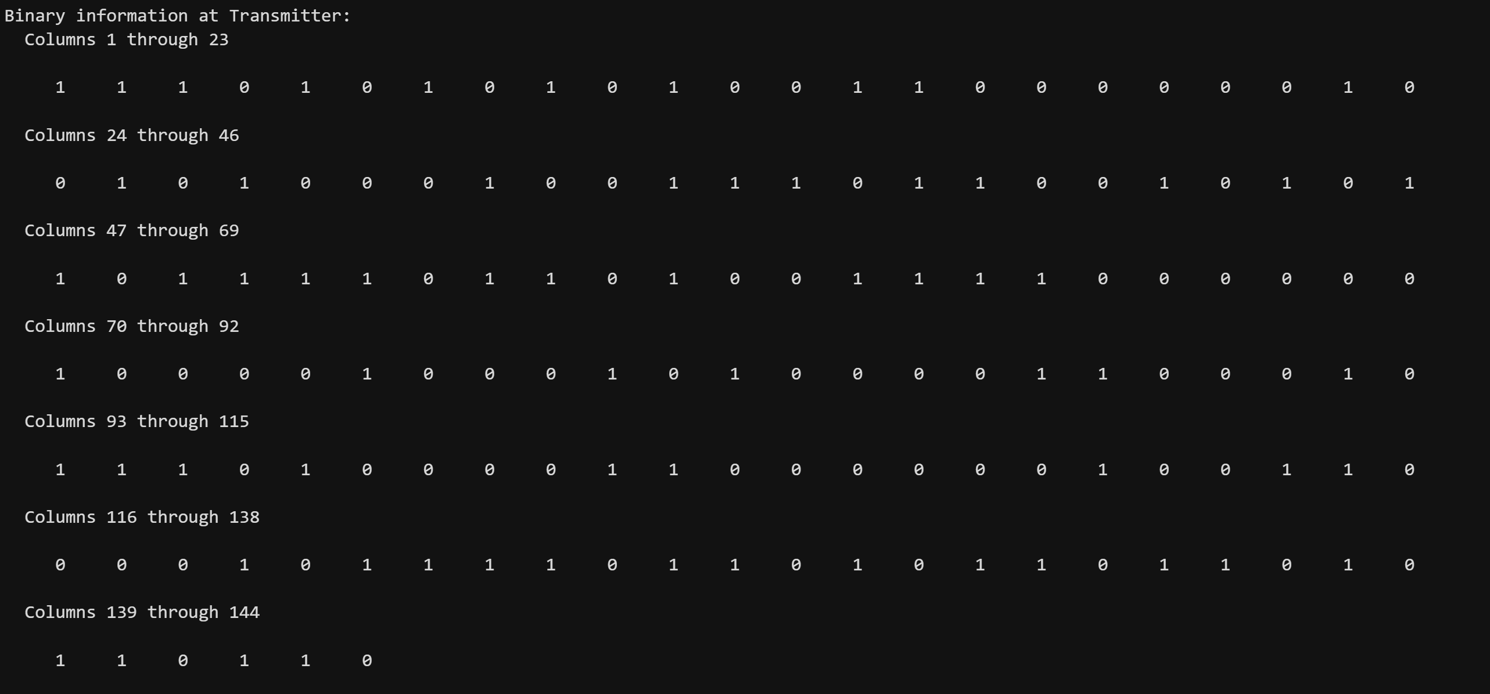
Fig3: Binary Information at Transmitter
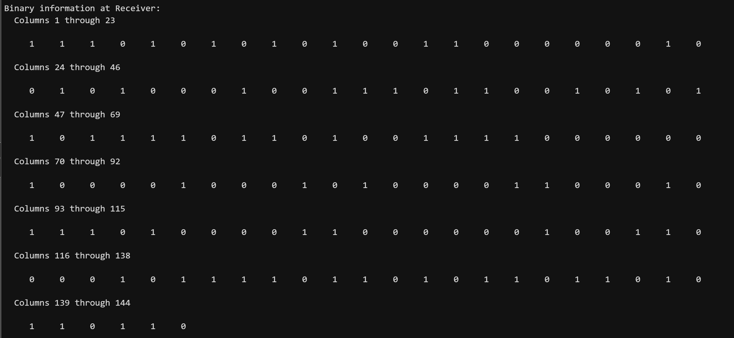
Fig4: Binary Information at Receiver
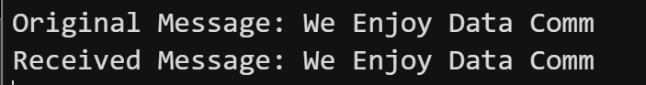
Fig5: Original & Received Message
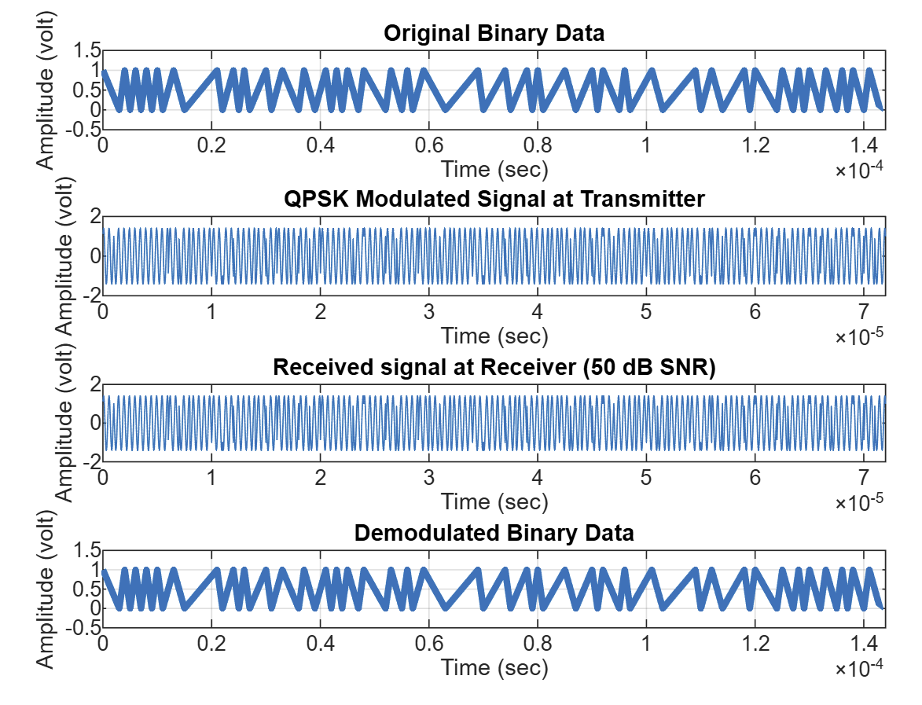
Fig6: Original Binary data to Demodulation Binary data
This experiment focused on transmitting and receiving a text message using Quadrature Phase Shift Keying (QPSK) modulation through a simulated communication channel. The process began by converting the message into binary form using ASCII encoding, which was then serialized into a digital signal. Using QPSK, the binary data was split into I (in-phase) and Q (quadrature) components, each modulated with cosine and sine carriers, respectively. This technique allowed efficient and compact signal transmission by representing two bits per symbol, improving bandwidth usage.
The addition of Additive White Gaussian Noise (AWGN) with a signal-to-noise ratio (SNR) of 50 dB simulated real-world channel conditions. Despite the presence of noise, the demodulation process—employing correlation and integration methods—successfully recovered the original binary stream. The separation of I and Q components and careful demodulation ensured accurate bit recovery, which was then decoded back into the original message. The received message matched the transmitted message exactly, confirming the robustness of QPSK in high-SNR environments.
The experiment highlighted the importance of proper signal processing in digital communication systems. It demonstrated how encoding, modulation, noise handling, and demodulation work together to ensure reliable data transfer. Through hands-on MATLAB simulation, we reinforced theoretical concepts such as bitstream generation, modulation techniques, and signal recovery. This practical approach not only validated the efficiency of QPSK modulation but also deepened our understanding of real-world communication system challenges and solutions.

Conclusion
This experiment successfully demonstrated the complete process of digital message transmission and reception using QPSK modulation. From message encoding to modulation, noise simulation, demodulation, and message decoding, each step was implemented effectively using MATLAB. The accurate recovery of the transmitted message, even in the presence of channel noise, validated the reliability of the modulation scheme.
The use of QPSK allowed efficient bandwidth usage while maintaining data integrity, showcasing its practical value in modern digital communication systems. Additionally, the experiment emphasized the significance of signal processing techniques such as bitstream synchronization, noise filtering, and carrier recovery.
Overall, the experiment enhanced our practical understanding of serial communication and modulation techniques. It bridged theoretical knowledge with hands-on implementation, preparing us to tackle real-world data communication challenges in engineering applications.

